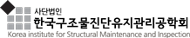 | 한국구조물진단유지관리공학회(22.10.5-7)  Reservation form
*Check In Date: 2022.10. |  | *Check Out Date: 2022.10. | 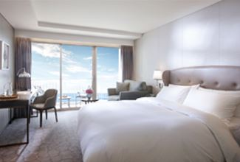  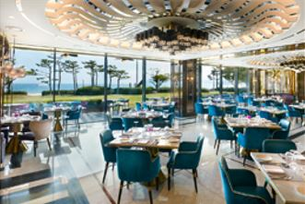  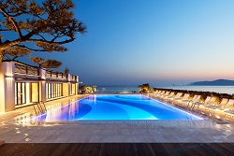
*No. of Persons:
*Name:
*Telephone: |  | *E-mail:
*CREDIT CARD FOR GUARANTEED
*Credit Card Type: ☐Etc. ☐Visa ☐Masters ☐Amex (4Digit-number : )
*Expiry Date:
*Credit Card Number:
*Card Holder’s Name:
DELUXE ROOM TYPE |  | *SPECIAL RATE (Mon~Thu.) | *SURCHARGE RATE
OCEAN TERRACE VIEW (본관) |  | ☐ KRW 278,300 (Twin Bed) | *Friday Surcharge:  KRW 72,600  * Saturday Surcharge:  KRW 145,200  * Sunday Surchage:  KRW 36,300
OCEAN TERRACE VIEW (신관) |  | ☐ KRW 302,500 (Double Bed)  ☐ KRW 302,500 (Twin Bed)
*Extra Bed/Bedding |  | ☐ KRW 72,600/ Night
*Breakfast Buffet |  | KRW 42,000/ Person.
Remark:
* The above mentioned room reservations may be closed in advance.(객실은 예약 상황에 따라 사전에 예약마감 될 수 있습니다)
* The rates above are non-commissionable, and they are Inclusive of 10% Service Charge and 10% Government Tax.
* The rates above are Not Included breakfast.
* Check-in time is 3p.m. Check out time is 11:00 a.m. (If you pass the check-out time, the following rates will apply)
(Until 3pm: 50% of the room rate, After 3pm: 100% of the room rate)
* FREE ACCESS: Ocean pool, Fitness Club, Business Center, Play Lab, Amenity, Internet(wifi)
* 50% Special Discount on admission to Sauna and Outdoor hot spring ‘Cimer’
* The spa facilities (Ocean pool, fitness club, Sauna, Cimer) are closed on the fourth Wednesday of every month.
CANCELLATION POLICY
* If you do not cancel on time, the hotel has the right to claim all room charge, which would be deducted from your guaranteed credit card. Cancellation or No-Show after the room reservation is being charged as below.
- From 7days to 5days prior to Arrival date : 30% of the Room charge
- From 4days to 3days prior to Arrival date : 50% of the Room charge
- From 2days or less prior to Arrival date : 100% of the Room chrarge
Please send your reservation form to: res@paradisehotel.co.kr (Tel no. +82.51.749.2111-3)

